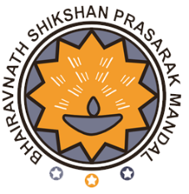
SHRI BHAIRAVNATH SHIKSHAN PRASARAK MANDAL'S

ADHALRAO PATIL INSTITUTE OF MANAGEMENT AND RESEARCH
Approved by AICTE New Delhi, Recognized by DTE Maharashtra & Affiliated to Savitribai Phule Pune University, NAAC Accredited
Address: At Post Landewadi (Via Manchar), Tal. Ambegaon, Dist. Pune – 410 503
Maharashtra, India. Tel.: 02133-235105

A

REPORT ON

“CELEBRATION OF MAHATMA JYOTIBA PHULE JAYANTI”

TUESDAY, 11TH APRIL 2023

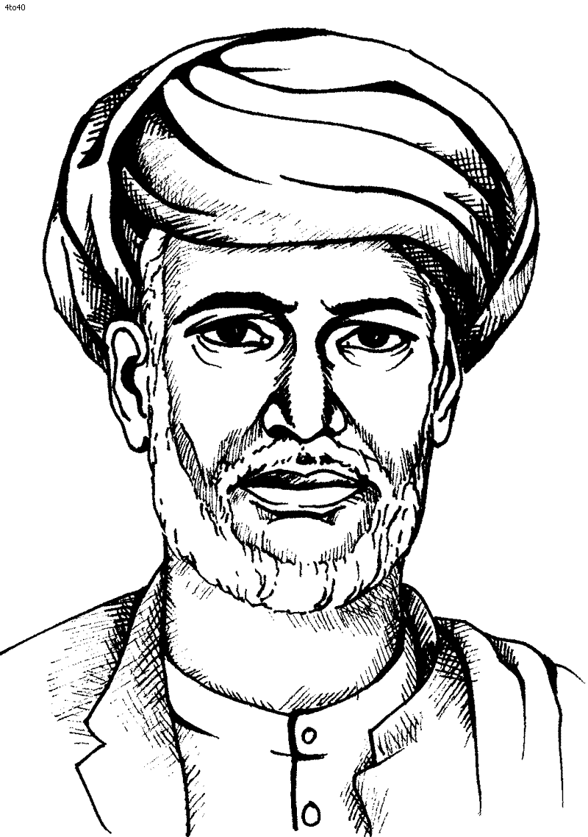

Dr. Umesh S. Kollimath  Academic Coordinator | Dr.Vishvajit S. Thigale  Coordinator | Dr. Vinod Sayankar  (Director, APIMR)

INDEX

SR. NO. | PARTICULARS | PAGE NO.
1 | REPORT | 3
2 | PHOTOGRAPHS | 4
3 | ATTENDANCE | 6
4 | NOTICE OF THE PROGRAM | 8

REPORT
CELEBRATION OF MAHATMA PHULE JAYANTI
Tuesday, 11 April 2023
SBSPM’s Adhalrao Patil Institute of Management and Research has celebrated the 196th birth anniversary of social reformer, educator and thinker Mahatma Phule on Tuesday, 11 April 2023 at 12.00PM at seminar hall.
Jyotirao Govindrao Phule (11 April 1827 – 28 November 1890) was an Indian social activist, thinker, anti-caste social reformer and writer from Maharashtra. His work extended to many fields, including eradication of untouchability and the caste system and for his efforts in educating women and oppressed caste people.
The program began with the formal inauguration at the hands of the Director of the institute Dr. V.N. Sayankar by offering flowers to the photograph of Mahatma Jyotiba Phule. He then addressed the staff and students on the contribution made by the Mahatma to the society and deprived people of the community. He said that “Mahatma Jyotiba Phule, was the country’s forerunner of social revolution, dedicated his life to the upliftment of the poor, women, and backward classes of the community, as well as the eradication of social inertia and evils.”
The director’s speech was followed by the speech by the academic coordinator Dr. Umesh Kollimath, Dr. Dhananjay Pingale and other staff. They also added major contributions made by this personality in shaping the society in the right direction.
The students also participated in the program by delivering their speech about the great personality. Ms. Sneha Thorat and Ms. Apeksha Nighot added a few words about the Mahatma and commemorated the birth anniversary of the Mahatma.
The program is concluded by the vote of thanks speech by the program coordinator Dr. Vishvajit S. Thigale.

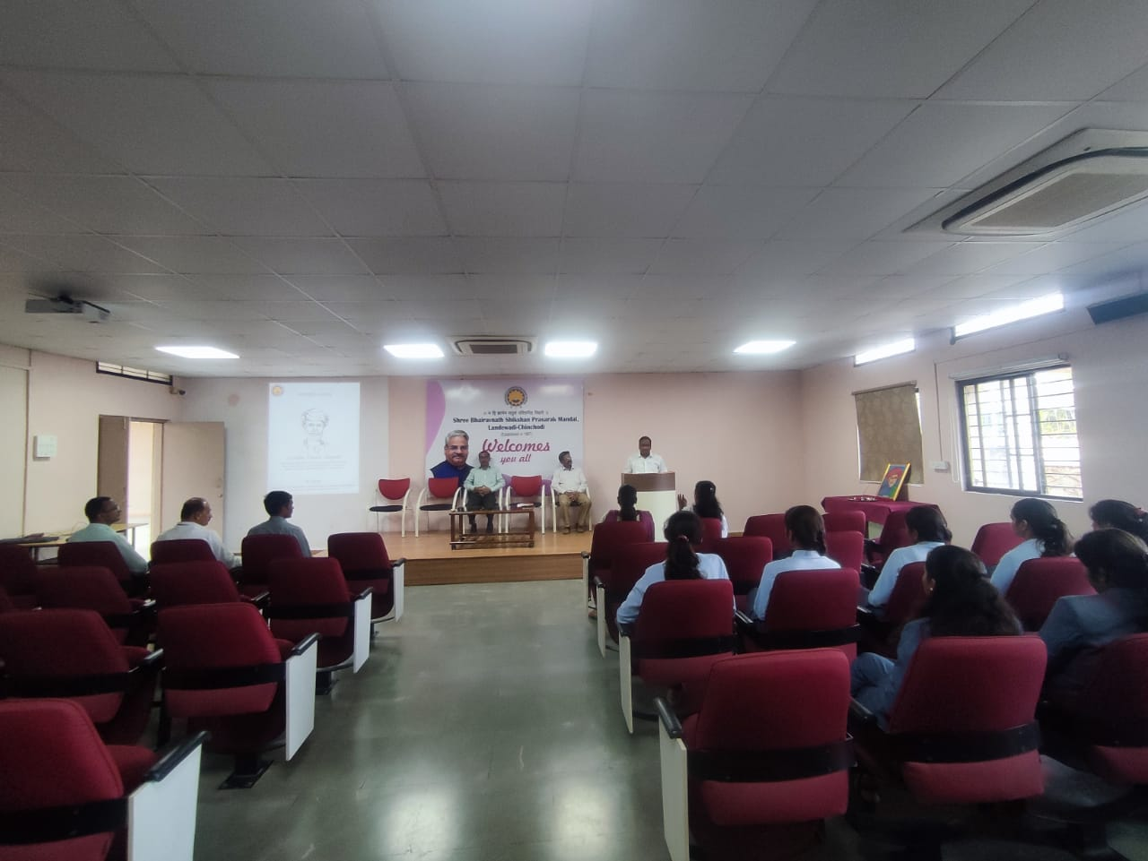
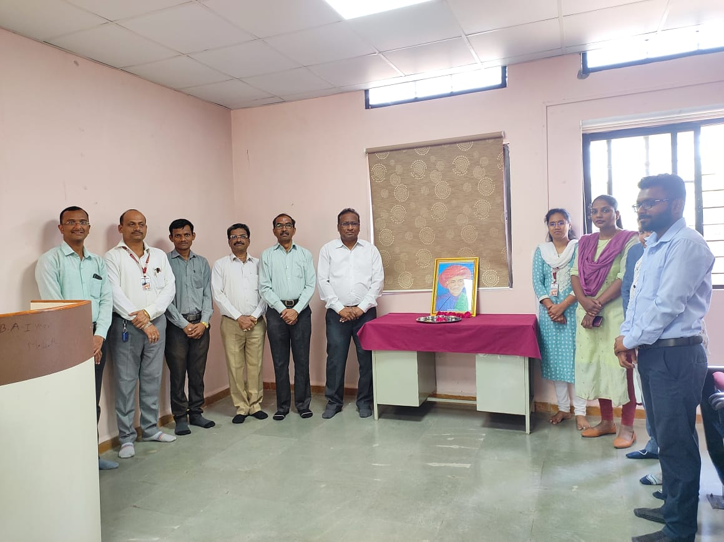
Director Dr. V.N. Sayankar, delivering speech on the contributions made by Mahatma Jyotiba Phule on 196th birth anniversary.

Commemoration of Birth Anniversary of Great Indian Social Activists and Reformer Mahatma Jyotiba Phule.
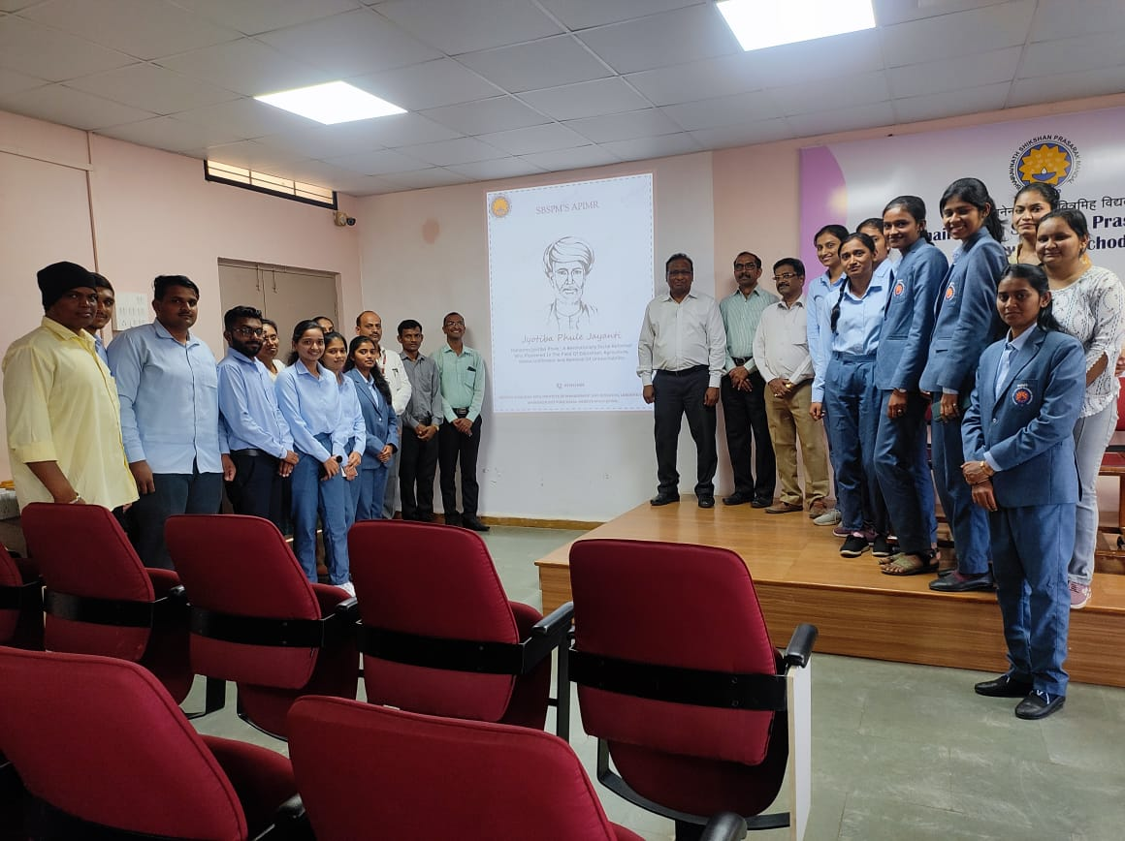

Students delivering speech on contribution of Mahatma Jyotiba Phule towards the society
